PRACTICAL: 5

**Aim:** Calculate cost estimation for your SGP project using LOC, Function Point and COCOMO.

**Software Required:** System Star Tool

**Knowledge Required:** Basics of Software Engineering

# Reports:

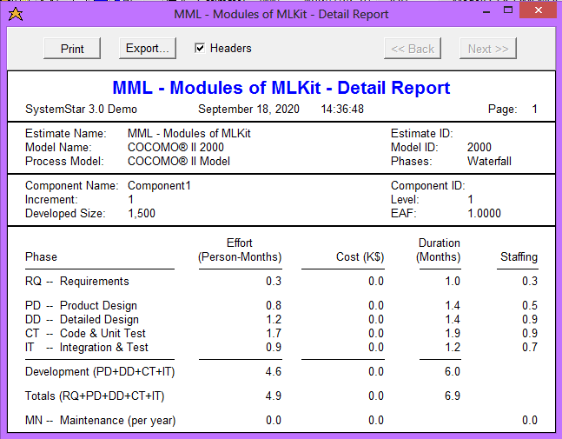



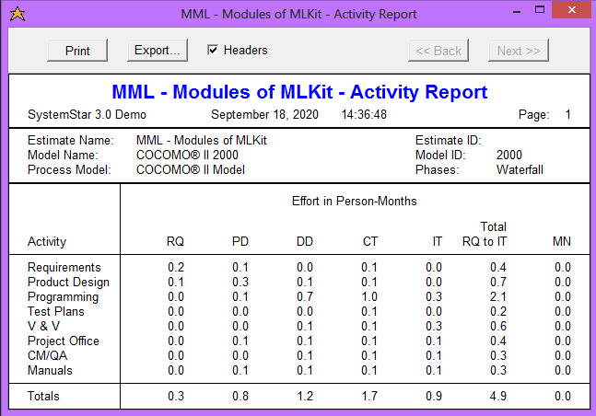

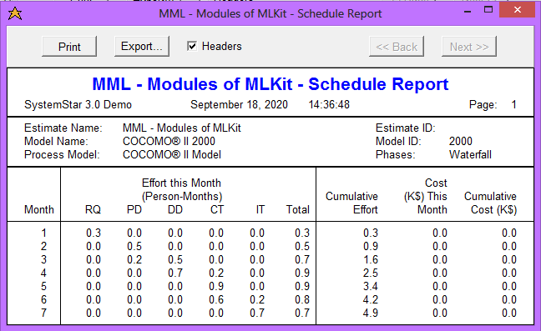



**Conclusion:**

By doing this practical I learned about LOC, COCOMO Model and using System star tool generated the reports for our ecommerce web application project.